LAB SET 1 ASSIGNMENT 2

BY PARUSH(102003404)

Qs 1,2)

#include <iostream>

using namespace std;

class complex{

float real,img;

public:

void setcomplex(float real,float img)

{

this->real=real;

this->img=img;

}

void displaycomplex()

{

cout<<real<<" "<<img<<endl;

}

complex add(complex c1,complex c2)

{

this->real=c1.real+c2.real;

this->img=c1.img+c2.img;

}

};

int main() {

complex c1,c2;

c1.setcomplex(10,20);

c1.displaycomplex();

c2.setcomplex(22,45);

c2.displaycomplex();

complex c3;

c3.add(c1,c2);

c3.displaycomplex();

return 0;

}

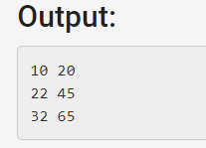

Qs3)

#include <iostream>

using namespace std;

int a=10;

class student{

public:

static int rollno;

int age;

void print(int rollno)

{

cout<<rollno<<endl;

cout<<student::rollno<<endl;

}

void function();

};

int student::rollno=10;

void student::function()

{

cout<<"function call"<<endl;

}

int main()

{

student s;

s.function();

s.print(100);

int a=20;

cout<<a<<endl;

return 0;

}

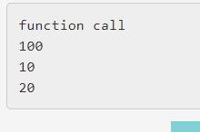

Qs4)

#include <iostream>

using namespace std;

namespace first

{

void func()

{

cout<<"first"<<endl;

}

}

namespace second

{

void func()

{

cout<<"second"<<endl;

}

}

int main ()

{

first::func();

second::func();

return 0;

}

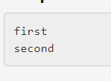

Qs5)

#include <iostream>

using namespace std;

class student

{

public:

student()

{

cout<<"constructor call"<<endl;

}

~student()

{

cout<<"destructor call"<<endl;

}

};

int main() {

student s1,s2,s3;

return 0;

}

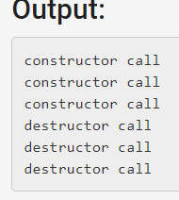

Qs6,7)

Class time discussion

LAB SET 2 ASSIGNMENT 2

Qs1)

#include <iostream>

#include<bits/stdc++.h>

using namespace std;

class student{

char\* Name;

int RollNo;

int Degree;

char Hostel;

float CurrentCGPA;

public:

/\*void addDetails(char\* Name)

{

this->Name=new student[strlen(Name)+1];

strcpy(this->Name,Name);

}\*/

void updatedetails(int RollNo,int Degree,char Hostel)

{

this->RollNo=RollNo;

this->Degree=Degree;

this->Hostel=Hostel;

}

void updatecgpa(float CurrentCGPA)

{

this->CurrentCGPA=CurrentCGPA;

}

void displaydetail()

{

cout<</\*Name<<" "<<\*/RollNo<<" "<<Degree<<" "<<Hostel<<" "<<CurrentCGPA<<endl;

}

};

int main() {

student s;

//s.addDetails("sdnjds");

s.updatedetails(10,2,'M');

s.updatecgpa(22.23);

s.displaydetail();

}



Qs2)

#include <iostream>

using namespace std;

class complex{

float real,img;

public:

void setcomplex(float real,float img)

{

this->real=real;

this->img=img;

}

void displaycomplex()

{

cout<<real<<" "<<img<<endl;

}

complex add(complex c1,complex c2)

{

this->real=c1.real+c2.real;

this->img=c1.img+c2.img;

}

};

int main() {

complex \*c1 =new complex;

complex \*c2 =new complex;

c1->setcomplex(10,20);

c1->displaycomplex();

c2->setcomplex(22,45);

c2->displaycomplex();

complex \*c3 =new complex;

c3->add(\*c1,\*c2);

c3->displaycomplex();

delete c1;

delete c2;

delete c3;

return 0;

}

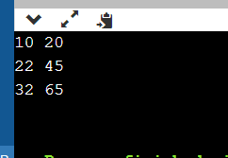

Qs3)

Same qs (set 1 ass 2qs3)

Qs4)

#include<iostream>

using namespace std;

class student{

int a;

void func1(int a)

{

cout<<"func1"<<endl;

this->a=a;

cout<<a<<endl;

}

public:

void func2(int a)

{

func1(a);

cout<<"func2"<<endl;

}

void print()

{

cout<<a<<endl;

}

};

int main()

{

student s;

s.func2(10);

s.print();

}

